**CHECK FOR…**

**CONVENTION**

* Limit to number of | TIP per Step? General advice about WCN: use sparingly
* | CAUTION color - Is there ANYTHING yellow about it? Balabit convention
* WARNING CAUTION NOTE, TIP (+ important, video, mobile, etc)
* Why are - suffix, numeral, example in monospace? MONOSPACE: commands, actions & their parameters  
  What else needs to be put in monospace? + userinput, path, filename
* What needs to be put in bold? GUI elements
* Is there anything that needs to be italicized? atm @Balabit: “Optional step” italicized + bulleted lists, similar examples (for visual separation)
* Is there anything that needs to be underlined? Not for xlink or hyperlink (comes from stylesheet and tags)
* “field” and “tab”: necessary, optional, or redundant? Seems inconclusive  
  Observation: with GUI elements and with “Click” imperative they seem to be used less often.
* Convention for introducing xlink / xref / external link?  
  For (further/more) details/info about (...) see …

**FACTUAL / TECHNICAL INFO**

* RDP Control > Settings : What does the X button do? SPS_5.8_scb-guide-admin: no clue found yet
* How does hyperlinking work in tag editor / HTML / XML / Flare / other? later
* Do I need to underline the hyperlinked text? Usually not, comes from style sheet
* How would I put a cross-reference to a different procedure in the Flare document? later
* **Technical terms for items like “menu bar”, “tab”, “field”, “panel”**

[**https://en.wikipedia.org/wiki/List_of_graphical_user_interface_elements**](https://en.wikipedia.org/wiki/List_of_graphical_user_interface_elements)

[**https://www.usability.gov/how-to-and-tools/methods/user-interface-elements.html**](https://www.usability.gov/how-to-and-tools/methods/user-interface-elements.html) **(!!!)**

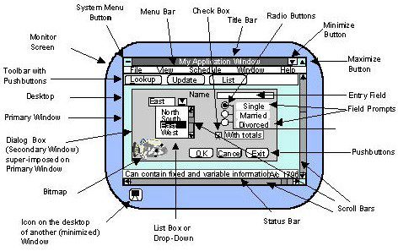

* Network overload - what does it lead to? (data loss or other?) research in progress

perhaps here? https://en.wikipedia.org/wiki/Network_congestion

**TECHNICAL TERM / LANGUAGE**

* (... ), if unsure, (...) - Is this OK?

In SPS_5.8_scb-guide-admin it is used: **If you are unsure about which settings to amend, then contact our Support Team for assistance**

* “preferred” value - Is this OK? Inconclusive - “Preference” is used often, just like “... the ( ) of your preference

**OTHER**